Tech Selector

Business Requirements Document

Project: Tech Selector

Author(s): Aayushi Shah, Ajay Gupta, Shreya Niphade, Elsa Poonawala, Noah Weitz, Darsh Jalan, Daksh Jasani.

Table of Contents

**1.** **Project Overview** 3

**2.** **Document Information** 3

2.1 Audience 3

**3.** **Business Opportunity** 3

3.1 Project Overview and Background 3

3.2 Current State Analysis 4

3.3 Future State Objectives 4

3.4 Business Domain Model and Stakeholders 4

**4.** **Business Requirements** 4

4.1 Details of Business Requirements 5

**5.** **Non-Functional Requirements** 6

**6.** **External Data Feeds** 7

**7.** **Business Risks** 7

# **Project Overview**

This document describes the business/user requirements for the Tech Selector Website that will provide the basis for the following project activities:

* Introducing business/user requirements
* Creating test plans and test specifications
* Identifying stakeholders
* Devising solutions to project tasks
* Produce a website that will enable user to discover and select personal electronics that fits their needs.
* Determining when the project is complete
* Assessing the degree to which the project succeeded

# **Document Information**

## 2.1 Audience

|  |  |  |
| --- | --- | --- |
| Name | Business Group | Role |
| Ad Agencies | Marketing Department | Partner/Supplier |
| Tech Companies | Electronics Department | Partner/Supplier |
| Delivery Companies | Orders & Delivery Department | Partner/Supplier |
| Payment Merchants | Payments Processing Department | Partner/Supplier |
| Customers | Orders & Delivery Department, Customer’s Service Department | Web Application Users |

# **Business Opportunity**

## 3.1 Project Overview and Background

The goal is to create a website that will provide users with a user-friendly interface that will allow them to browse the variety of gadgets and find their best fit after telling our program what kind of features are needed, customer will quickly be able to decide their best fit be it any area of interest/purpose (gaming/schooling/work etc..). This website will also include other electronics devices such as mobile phones, refrigerators, headphones. This website will also show comparison amongst the two devices. This website will also offer the ability to create the list of favorite products, rate the products and leave the reviews for the products.

## 

## 3.2 Current State Analysis

Personal electronic devices are more important than ever in the modern age, yet people still seem to have trouble figuring out what device is right for them among thousands of options. We intend to make the selection process easier by suggesting devices that will fit a user’s individual needs. After telling our program what kinds of features are needed, customers will soon be able to select a device that will be perfect for their intended use case whether that be gaming, work, web browsing, school, or any other potential need. This way, people can become more connected to the world at large and more efficient overall. Example for this website is PC Part Picker, Newegg. Tech Selector will provide consumers with a similar service utilizing an attractive and intuitive interface. The project will be written in JavaScript and will use a relational database MySQL. The planning process for this website is currently underway, and the development of the project will span two semesters at Pace University.

## 

## 3.3 Future State Objectives

The objective is to create the website that will be able to compete in the very crowded marketplace of Electronics. This website will also direct user to those websites where they can get the best deals for their selected electronic gadget. We might also add news section in our website so that our users can stay up to date with respect to electronic devices.

## 

## 3.4 Business Domain Model and Stakeholders

|  |
| --- |
| Stakeholders |
| Original Equipment manufacturers |
| Other hardware manufacturers |
| Marketing team |
| Electronics Retailers |
| Manufacturers |
| Digital Media Ad Agencies |
| Potential customers |

BRM DIAGRAM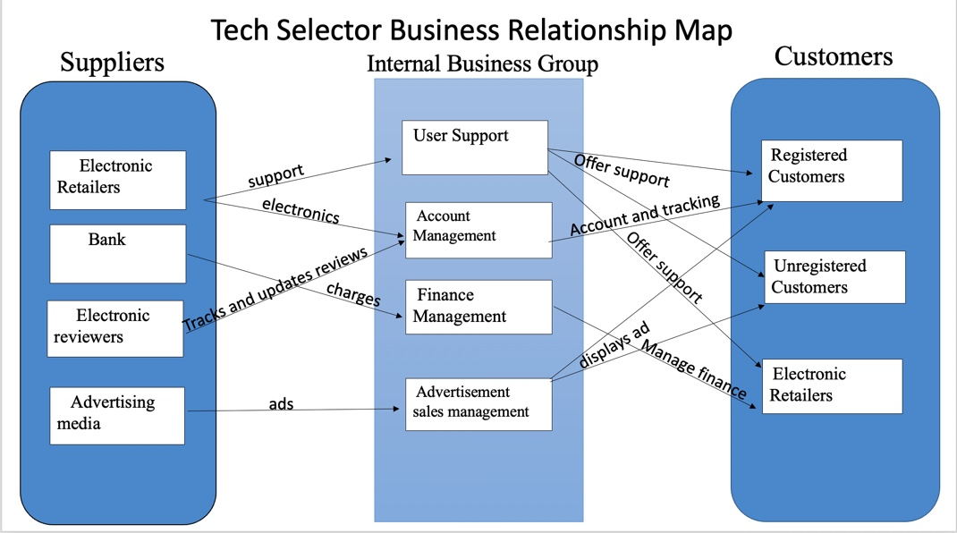

# **Business Requirements**

The primary users of the Tech Selector Website will be able to create the account and browse through various electronic gadgets and compare different products by filtering out the specifications. The portal will provide customers with a user-friendly interface that will allow them to search for electronic gadgets and then do comparison for the products they are looking for by searching and selecting the name of product. The application will also allow users to create the profile and look for retailers that have products in best available price and customers can get redirected to that website.

## 4.1 Details of Business Requirements

* + 1. **Advertisement sales Department** 
       1. Ability to log in
       2. Ability to generate ads on the website
       3. Ability to maintain content of an ad
       4. Ability to filter ads content
       5. Ability to keep ads up to date
       6. Ability to do market analysis
       7. Ability to understand product performance
       8. Ability to promote sponsored posts
       9. Ability to view user browsing history within the website only
       10. Ability to filter advertisements list on Design Hub
       11. Ability to keep ads up to date
       12. Ability to advertise the products
    2. **User Support Department**
       1. Ability to respond effectively through the customer support page
       2. Ability to update the open ticket as closed or resolved
       3. Ability to provide the customers with ticket resolution
    3. **Finance Management Department**
       1. Ability to process the advertisement payments
       2. Ability to process retail merchandise payments
       3. Ability to apply/issue discounts
    4. **Account Management**
       1. Ability to create an account
       2. Ability to delete the account
       3. Ability to modify the account information
       4. Ability to restore the password/user ID details
       5. Ability to sign in to (sign out from) already created account
       6. Ability to read the product information
       7. Ability to submit the form to customer support
       8. Ability to read the resolution of the opened ticket with customer support team
       9. Ability to share the product on social media
       10. Ability to make product favorite
       11. Ability to view the list of favorite products
       12. Ability to leave the reviews
       13. Ability to rate the products
    5. **Registered Customers**
       1. Ability to login
       2. Ability to review the products
       3. Ability to compare products
    6. **Unregistered Customers**
       1. Ability to compare products
       2. Ability to lookup products
       3. Ability to read reviews of products
    7. **Electronic Retailers**
       1. Ability to access the website
       2. Ability to add products
       3. Ability to edit products
       4. Ability to add link of products

# **Non-Functional Requirements**

|  |  |
| --- | --- |
| **Category** | **Requirements** |
| **Usability** | Website GUI will provide a user-friendly intuitive design with all the features clearly displayed for the user |
| **Usability** | Website navigation will be self-explanatory by clear and concise descriptions and names of each section, as well as features will be clearly evident by proper location and naming |
| **Usability** | Accessibility will be supported for the disabled users as well |
| **Performance** | This website will be supported on different operating systems and browsers, and should not impact the user’s system capabilities |
| **Performance** | This website will be available for 24/7 without any interruptions, and regular maintenances will be scheduled to support the website |
| **Performance** | This website will support the concurrency where the users will be able to simultaneously browse the website. |
| **Security** | This website will be using the automated daily & weekly audits to detect the vulnerabilities. |
| **Security** | This website will use HTTPS protocols for any data exchanges and other encryptions that will be maintained on the server |
| **Database** | This website will be using the MySQL database |
| **External System** | This website will be able to interface with the external data feeds, ad agencies, social media websites, etc.… |

# **External Data Feeds**

* **Provide Device Information**
  + Allows customers to retrieve the device information which customers have searched.
  + Compare the products and then the information of device is displayed.
* **Refers customers**

Enables the customers to check retail merchandise that have the electronics that customers are looking for.

Redirects customer to the website where customers can find best deals for the products.

* **Handles and Revenue**

The advertisements that are generated on website earn from displaying paid advertisements on their website.

The more people that see the product, the more likely is people will purchase. The advertisements like BestBuy have a Christmas deal on iPhone.

* **Provide Review Score**

Feeding the website with the reviews of customers on the products.

Tech Selector will be predicting the rating user would give to a device. Then reviews are filtered accordingly newer to older.

# **Business Risks**

Our website is targeting a niche market of specific individuals who wants to learn about the electronic gadgets before buying. Nowadays people are more concern about buying right gadgets, so the competition will be on the rise for our business. Competition risks will be mitigated by differentiating our products from others on the market by adding new launches of phones, laptops, cameras. In addition, we will keep the older versions too because most people think of comparing older versions with newer versions to see what new features have been added in the product. So, we will be having some outdated products. We are also offering the features like filtering out the prices of the product so that customer can get a clear picture of products. Constantly analyzing the market and product performances we will be able to work on and introduce new features to be added to the website to keep the current clients and attract new customers. Market and product performance will also allow us to come up with successful product offerings. Therefore, one key strategy to mitigate this risk is by keeping our website user-friendly, simple to use with a continually growing list of QoL (quality of life) features that makes product browsing less of a hassle for users.

On the technical side the company can face the risk of the software malfunctioning and products not being updated on time. There is a constant concern of vulnerabilities such as SQL Injection (SQLI), Cross-Site Scripting (XSS), Traversal Directory (TRV), Local File Inclusion (LFI) and Remote File Inclusion (RFI), Shell Code Injection, Directory Indexing (DI), Open Redirect (ORED), File Discover (FD), Common Vulnerabilities & Exposures (CVE) and others. The Website will be subjected to automated daily & weekly audits to detect the vulnerabilities. It will also use HTTPS protocols for any data exchanges, enforced TLS for all the email communications, and other encryptions that will be maintained on the server. There is also a risk of website not being able to adapt to the new technologies fast enough to support the website and stay competitive on the market. Maintaining and reusing the requirements and following the AORA will help our business to adapt faster to changes and develop new and upgraded features with ease and without waste of time on starting the projects from scratch.